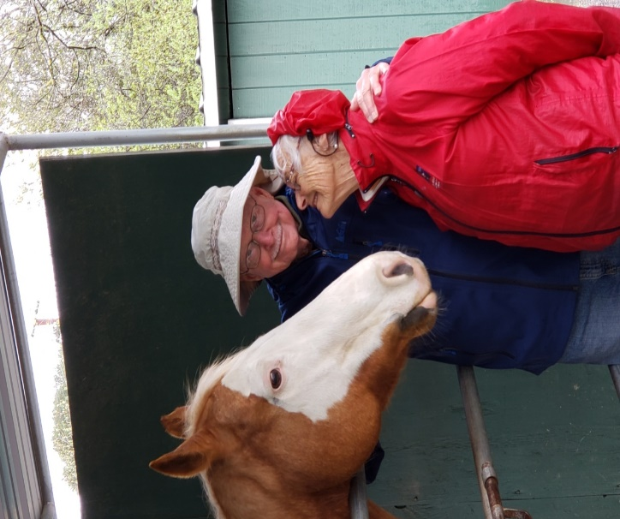
CONNECTED HORSE WORKSHOPS at
Xenophon
Therapeutic Riding Center
Orinda, CA

Based on research conducted at Stanford University and UC Davis, our workshops are designed to benefit people with memory changes and early-stage dementia along with their primary care partner (family member or friend). Through therapeutic equine-guided workshops both participants report reduced stress, enhanced communication, greater awareness, as well as a decrease in feelings of depression and anxiety. Together they enjoy a unique shared experience, new social connections and FUN.
Upcoming Workshops
April 19, 26, May 3, 10 (Wednesdays)
June 6, 13, 20, 27 (Tuesdays)
No prior horse experience is necessary
Activities with horses are on the ground, no riding
All participants must be able to walk unassisted
FREE to participate, though donations are gratefully accepted

For more information or to register contact Penny Sinder (925) 377-0871
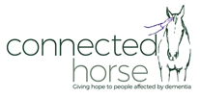
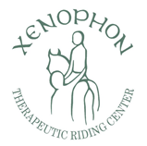
penny@xenophontrc.org www.xenophontrc.org/connectedhorse

